TITLE: BASIC LOGIC GATE DESIGN
1. Images/Visuals to Include
1.Logic Gate Symbols
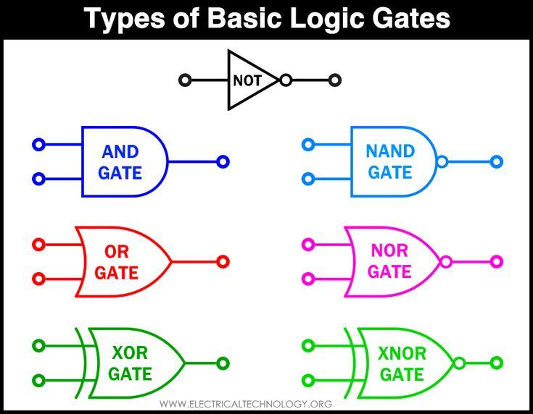
Logic gates and Boolean algebra form the fundamental building blocks of digital
electronics and VLSI design. They enable us to represent, analyze, and design complex
digital systems using binary values — 0s (false) and 1s (true).
Logic Gates
Logic gates are basic electronic components that perform logical operations on one or
more binary inputs to produce a single binary output. The primary logic gates are:
1.AND Gate
Output is 1 only when all inputs are 1
Symbol: A · B or AB
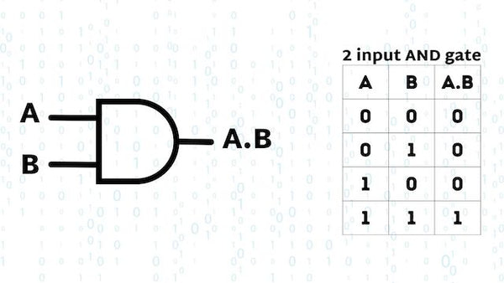

2.OR Gate
Output is 1 if at least one input is 1
Symbol: A + B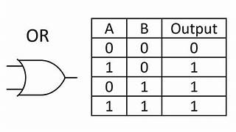
3.NOT Gate (Inverter)
Produces the opposite of the input
Symbol: ¬A or A ̅
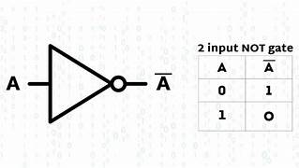
4.NAND Gate
Inverse of AND gate
Output is 0 only when all inputs are 1
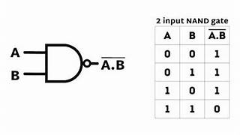

5.NOR Gate
Inverse of OR gate
Output is 1 only when all inputs are 0
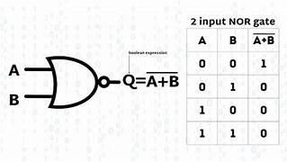

6.XOR Gate (Exclusive OR)
Output is 1 when inputs are different
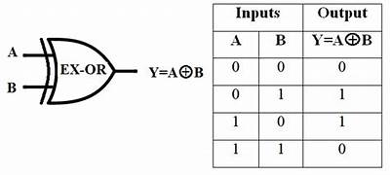
7.XNOR Gate (Exclusive NOR)
Output is 1 when inputs are the same
These gates can be physically implemented using CMOS technology, with NMOS and
PMOS transistors configured to produce the desired logic
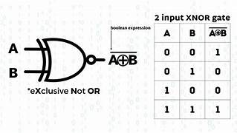
Boolean Algebra
Boolean algebra is a mathematical framework used to analyze and simplify logic
circuits. It uses variables that take values of 0 or 1 and provides a set of operations and
rules to manipulate them.
Basic Boolean Operations:
1.AND (·)
A · B = 1 only when both A and B are 1
2.OR (+)
A + B = 1 when at least one of A or B is 1
3.NOT (¬ or ̅ )
¬A = 1 if A = 0, and vice versa
Important Laws of Boolean Algebra:
1.Identity Law
A + 0 = A
A · 1 = A
2.Null Law
A + 1 = 1
A · 0 = 0
3.Idempotent Law
A + A = A
A · A = A
4.Complement Law
A + A ̅ = 1
A · A ̅ = 0
5.Distributive Law
A · (B + C) = A·B + A·C
6.DeMorgan’s Theorems
¬(A · B) = A ̅ + B ̅
¬(A + B) = A ̅ · B ̅
These are crucial for simplifying logic expressions, especially for designing with
NAND and NOR gates
Applications in Digital Design
Using Boolean algebra, complex logic expressions can be simplified to reduce the
number of gates and transistors needed in a circuit. This leads to more efficient and
cost-effective VLSI designs. Tools like Karnaugh Maps (K-maps) and Quine-McCluskey
method are used to visually and systematically minimize Boolean expressions.
In summary, logic gates perform the operations, and Boolean algebra provides the
tools to describe and simplify those operations mathematically. Together, they form
the core of digital design and are essential for understanding how data is processed in
digital systems.

2.CMOS Logic Gate Visuals
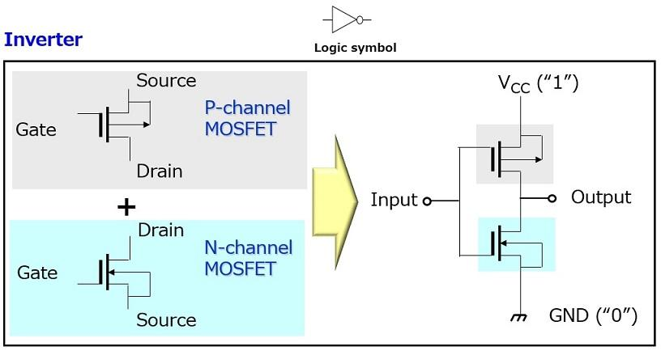
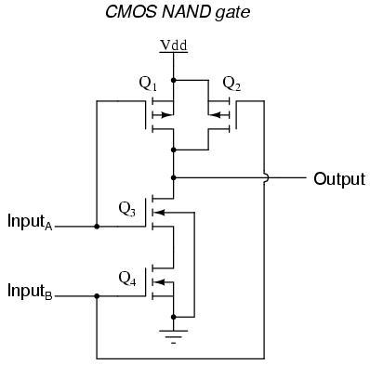
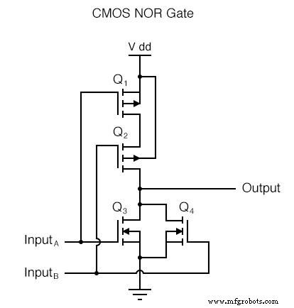

3. Research Material
Topics to Study
- Binary Number System
- Boolean Algebra
- Digital Logic Design
- CMOS Technology
- VLSI Basics
- Universal Gates
- Combinational Logic Circuits

Key Formula
Boolean identities:
- A + 0 = A
- A · 1 = A
- A + A = A
- A · A = A
- A + A' = 1
- A · A' = 0
4. Dataset for Project
Input A | Input B | AND | OR | NAND | NOR | XOR | XNOR
0 | 0 | 0 | 0 | 1 | 1 | 0 | 1
0 | 1 | 0 | 1 | 1 | 0 | 1 | 0
1 | 0 | 0 | 1 | 1 | 0 | 1 | 0
1 | 1 | 1 | 1 | 0 | 0 | 0 | 1
This table can be used as your project dataset.

